**SQL Mini Project On Bank Management System**

**About This Project:**

A bank management system is a computerized system that helps manage the various operations of a bank.

SQL (Structured Query Language) is a programming language used to manage and manipulate data stored in relational databases. A SQL-based bank management system project would involve creating a database to store information about customers, accounts, transactions, and other relevant bank information.

The system would then use SQL to query and manipulate this data to perform various tasks such as depositing and withdrawing funds, transferring money between accounts, and generating reports.

**Source Code:**

**#Create a database called "BMS"**

**create** **database** BMS;

**#Using BMS Database To Perfom All Activities:**

use BMS;

**#Create a table called "customers" to store customer information:**

**CREATE** **TABLE** customers (

id INT AUTO_INCREMENT **PRIMARY** **KEY**,

name VARCHAR(255) **NOT** **NULL**,

address VARCHAR(255) **NOT** **NULL**,

email VARCHAR(255) **NOT** **NULL**,

phone_number VARCHAR(255) **NOT** **NULL**

);

**#Create a table called "accounts" to store account information:**

**CREATE** **TABLE** accounts (

id INT AUTO_INCREMENT **PRIMARY** **KEY**,

customer_id INT **NOT** **NULL**,

account_number VARCHAR(255) **NOT** **NULL**,

balance DECIMAL(10,2) **NOT** **NULL**,

**FOREIGN** **KEY** (customer_id) **REFERENCES** customers(id)

);

**#Create a table called "transactions" to store transaction history:**

**CREATE** **TABLE** transactions (

id INT AUTO_INCREMENT **PRIMARY** **KEY**,

account_id INT **NOT** **NULL**,

transaction_type ENUM ('DEPOSIT', 'WITHDRAWAL'),

amount DECIMAL(10,2) **NOT** **NULL**,

**FOREIGN** **KEY** (account_id) **REFERENCES** accounts(id)

);

**#Insert data into the "customers" table:**

**INSERT** **INTO** customers (name, address, email, phone_number)

**VALUES**

("Rohit Shah", "21 A, New Delhi, Delhi 110001", "rohit.shah@gmail.com", "(91) 123-456789 "),

("Priya Patel", "12 B, Mumbai, Maharashtra 40001", "priya.patel@gmail.com", "(91) 987-654321"),

("Megha Singh", "56 D, Kolkata, West Bengal 700026", "megha.joshi@gmail.com", "(91) 258-903467"),

("Ravi Kumar ", "34 C, Bangalore, Karnataka 560001", "ravi.kumar@gmail.com", "(91) 246-807569"),

("Amit Singh ", "56 D, Kolkata, West Bengal 700026", "amit.singh@gmail.com", "(91) 135-798056"),

("Anil Kumar", "90 F, Hyderabad, Telangana 500028", "anil.kumar@gmail.com", "(91) 369-127580"),

("Neha Gupta", "12 G, Pune, Maharashtra 411057", "neha.gupta@gmail.com", "(91) 147-258369");

**#Insert data into the "account" table:**

**INSERT** **INTO** accounts (customer_id, account_number, balance)

**VALUES**

(1, "1234-5678-9012", 11000.00),

(2, "2345-6789-0123", 32000.00),

(3, "3456-7890-1234", 3001.00),

(4, "4567-8901-2345", 50000.00),

(5, "5678-9012-3456", 60000.00),

(6, "6789-0123-4567", 60020.00),

(7, "7890-1234-5678", 7750.00);

**#Insert data into the "transaction" table:**

**INSERT** **INTO** transactions (account_id, transaction_type, amount)

**VALUES**

(1, "DEPOSIT", 5000.00),

(2, "WITHDRAWAL", 200.00),

(3, "DEPOSIT", 1000.00),

(4, "WITHDRAWAL", 15000.00),

(5, "DEPOSIT", 3000.00),

(6, "WITHDRAWAL", 500.00),

(7, "DEPOSIT", 500.00);

**Queries:**

**#1 Retrieve a list of all customers:**

**select** \***from** customers;

**#2 Retrieve a list of all accounts:**

**select** \***from** accounts;

**#3 Retrieve a list of all transactions:**

**select** \***from** transactions;

**#4 Retrieve a specific customer by email:**

**select** \***from** customers **where** email="ravi.kumar@gmail.com";

**#5 Retrieve the balance of a specific account:**

**select** balance **from** accounts **where** account_number= "6789-0123-4567";

**#6 Retrieve the balance of a specific account:**

**SELECT** * **FROM** transactions **WHERE** account_id = 1;

**#7 Retrieve customer information and account information for a specific customer:**

**select** **c**.name, **c**.address, a.account_number, a.balance

**from** customers **c**

**join** accounts a **on** **c**.id = a.customer_id

**where** **c**.email = "anil.kumar@gmail.com";

**#8 Retrieve the name of the customer with the highest balance:**

**select** **c**.name

**from** customers **c**

**join** accounts a **on** **c**.id = a.customer_id

**where** a.balance = (**select** **max**(balance) **from** accounts);

**#9 Retrieve the total number of transactions for each customer:**

**select** **c**.name, **count**(t.id) **as** total_transactions

**from** customers **c**

**join** accounts a **on** **c**.id = a.customer_id

**join** transactions t **on** a.id = t.account_id

**group** **by** **c**.id;

**#10 Retrieve the average balance for all accounts:**

**select** **avg**(balance) **as** average_balance

**from** accounts;

**#11 Retrieve the name of the customer and their account balance for all accounts with a balance greater than a specified amount:**

**select** **c**.name, a.balance

**from** customers **c**

**join** accounts a **on** **c**.id = a.customer_id

**where** a.balance >= 1000;

**#12 Retrive the name of the customer, specific transaction type and their amount:**

**SELECT** customers.name, transactions.transaction_type, transactions.amount

**FROM** transactions

**JOIN** customers

**ON** transactions.id = customers.id

**WHERE** transactions.id **IN** (

**SELECT** id

**FROM** transactions

**WHERE** transaction type = 'deposit'

);

**Output With Each Query:**

**#Showing and using of database**

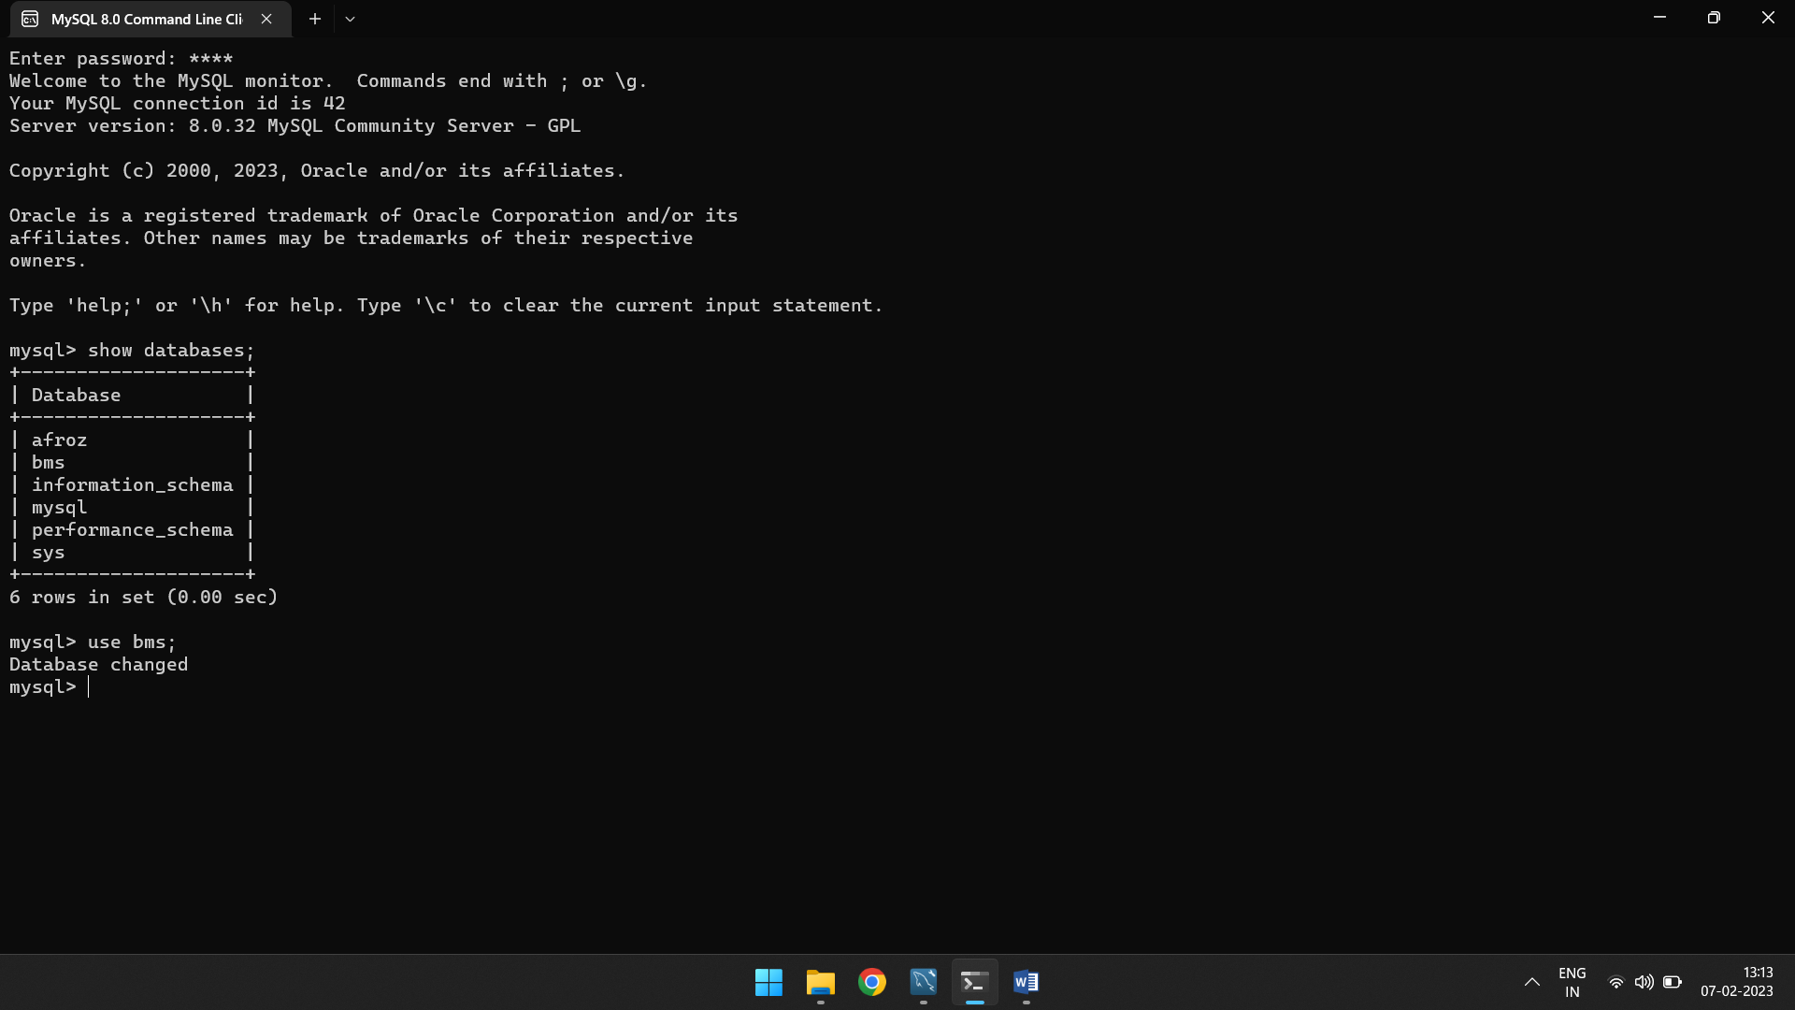

**#Showing Tables inside of database**

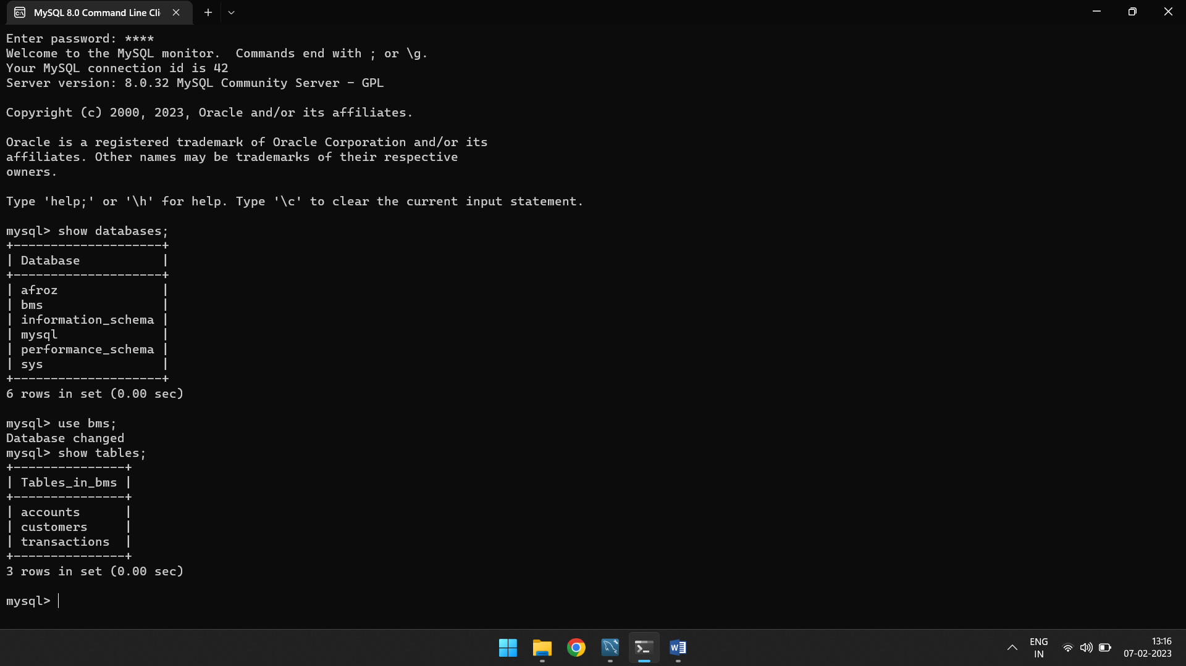

**#Retrieve a list of all customers:**

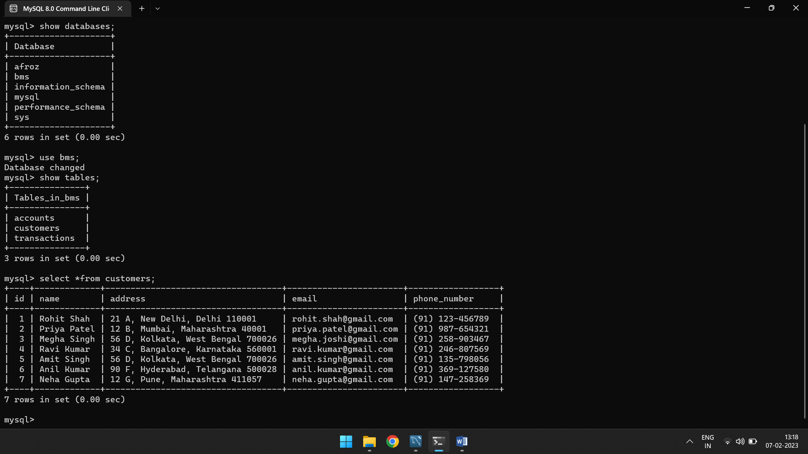

**#Retrieve a list of all accounts:**

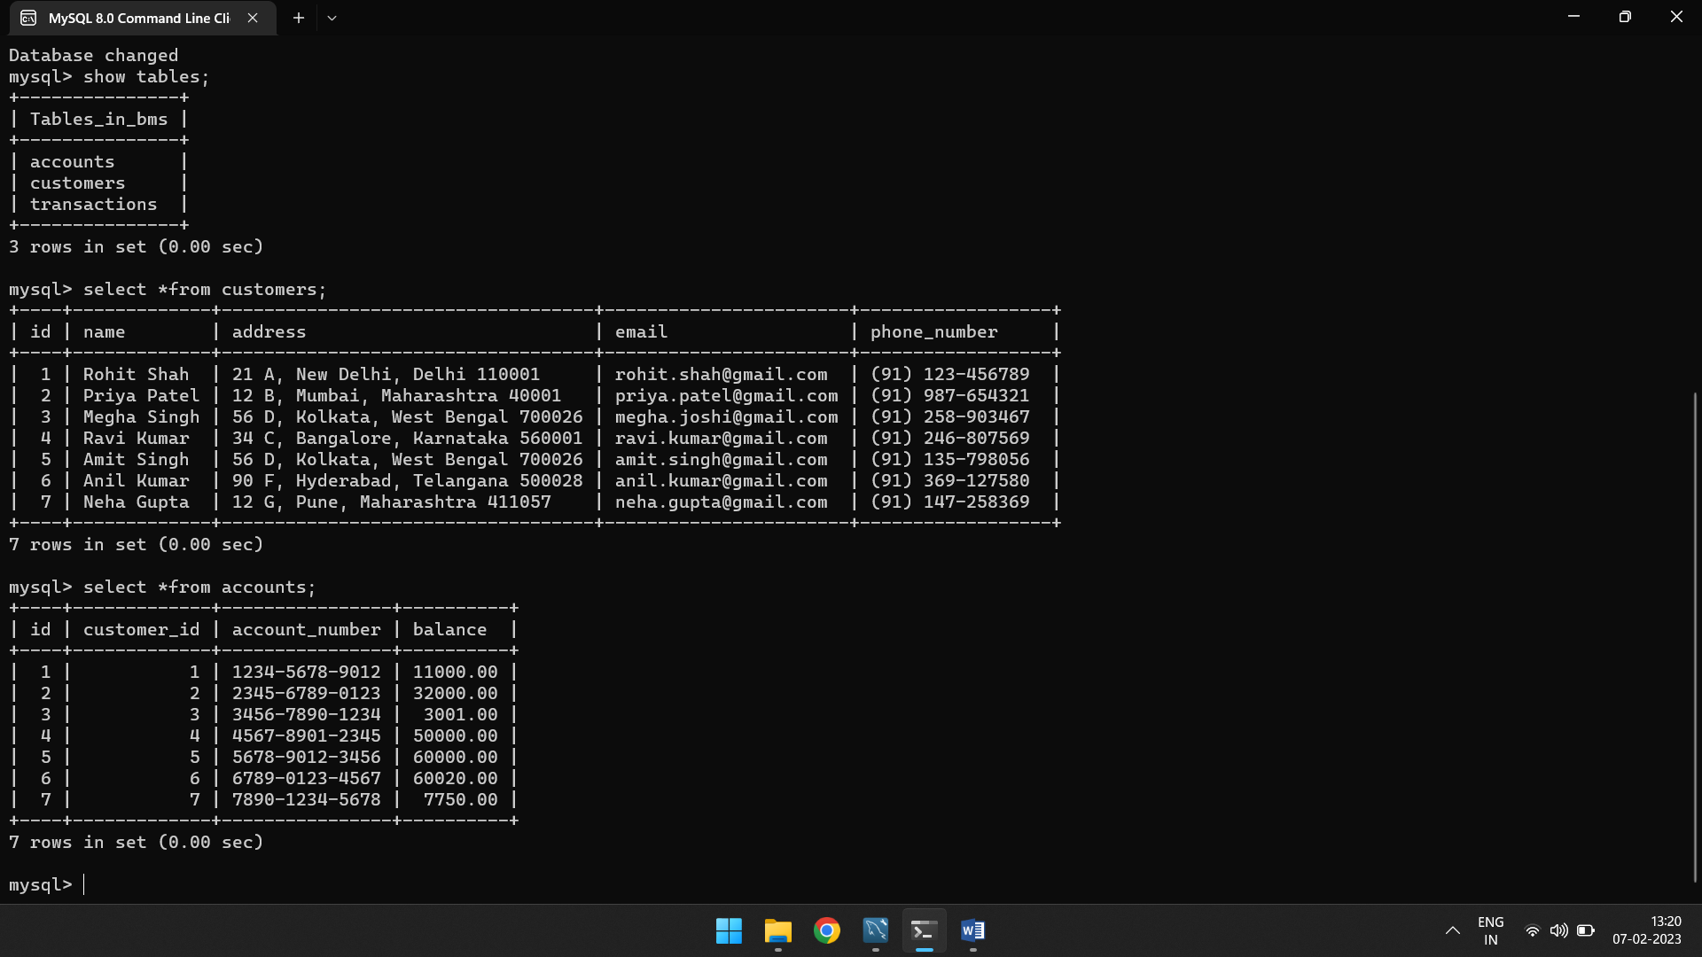

**#Retrieve a list of all transactions:**

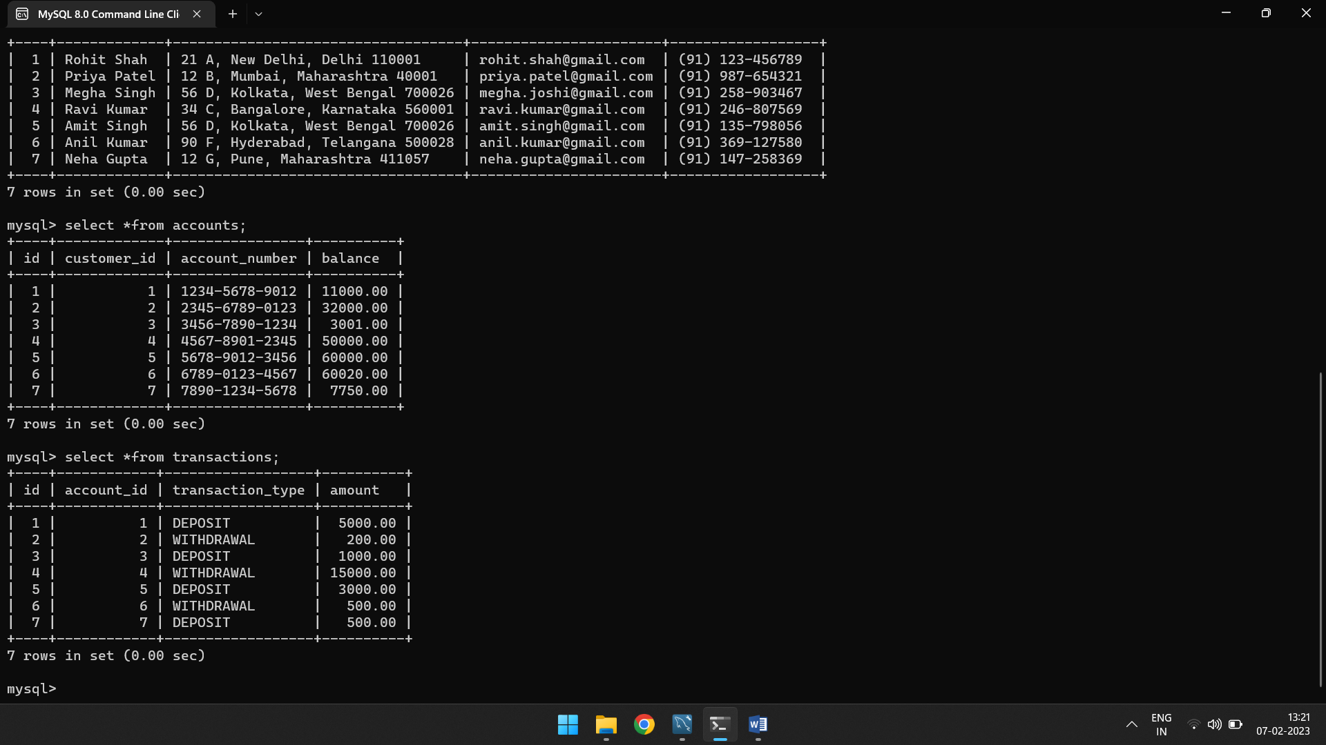

**#Retrieve a specific customer by email:**

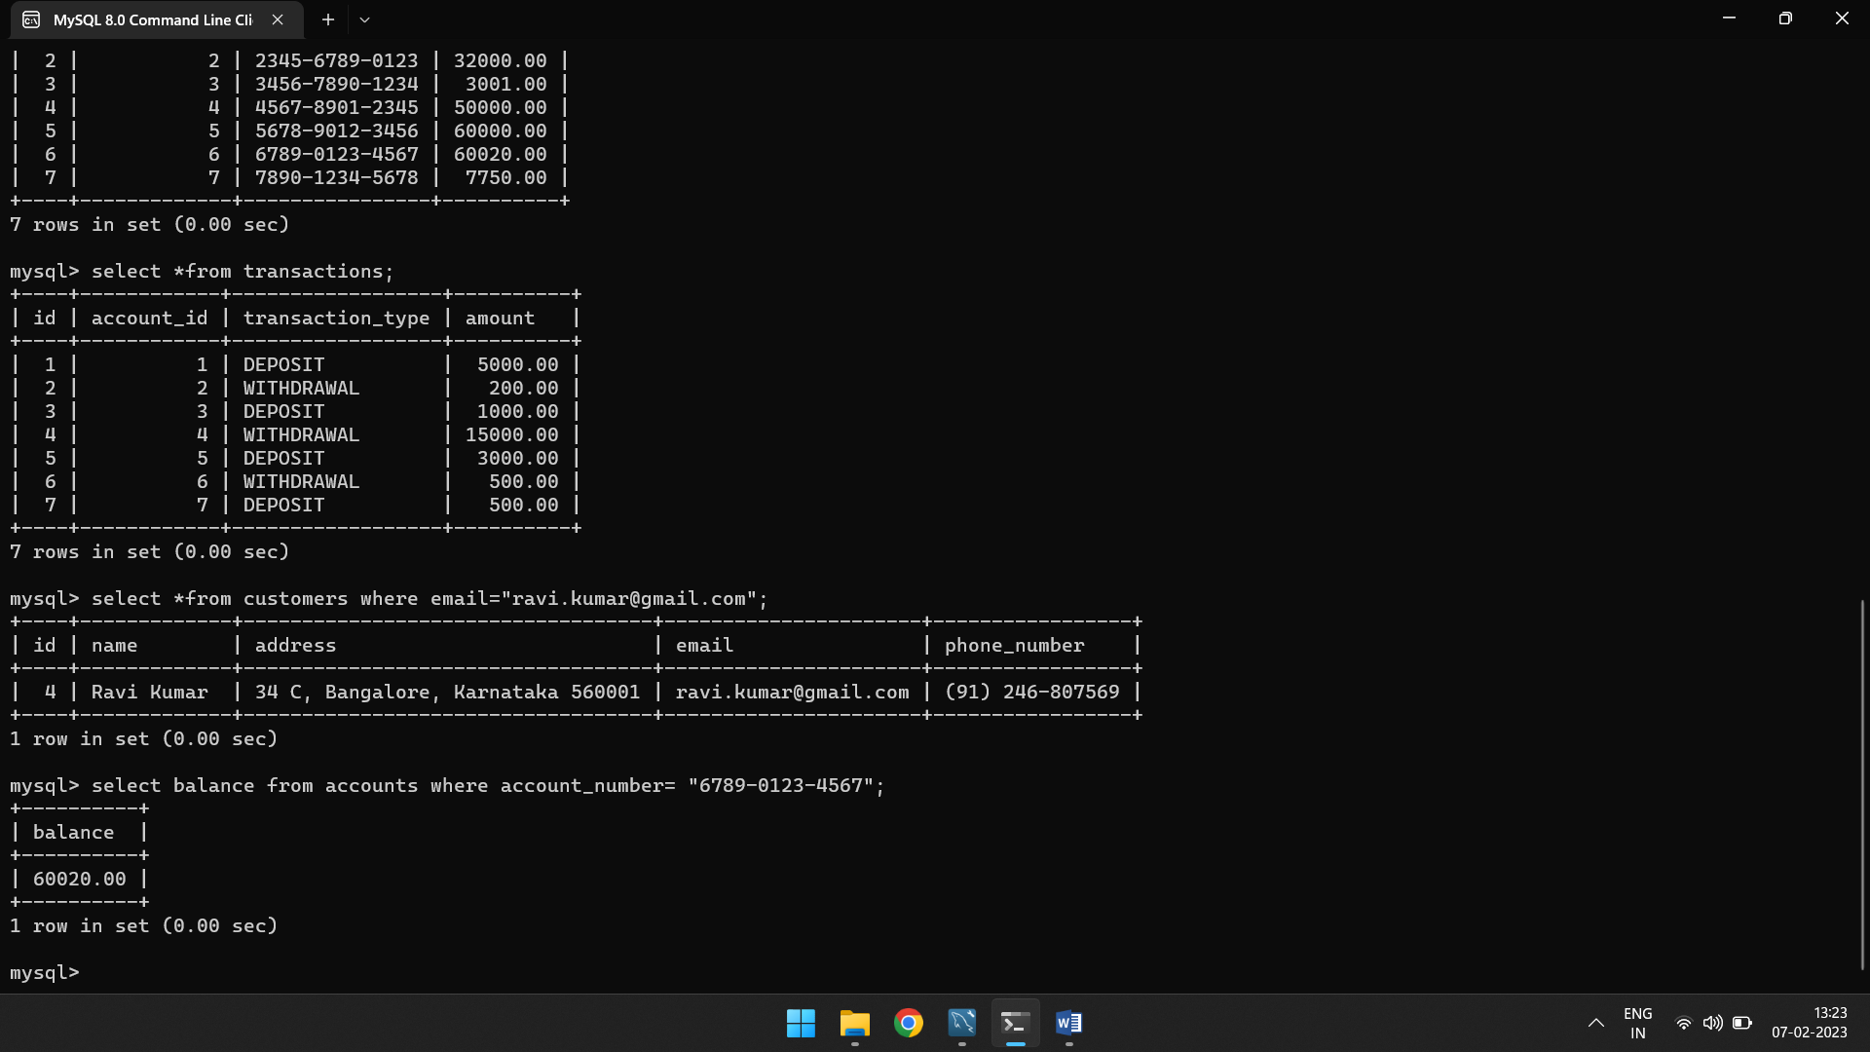

**#Retrieve the balance of a specific account:**



**#Retrieve the balance of a specific account:**

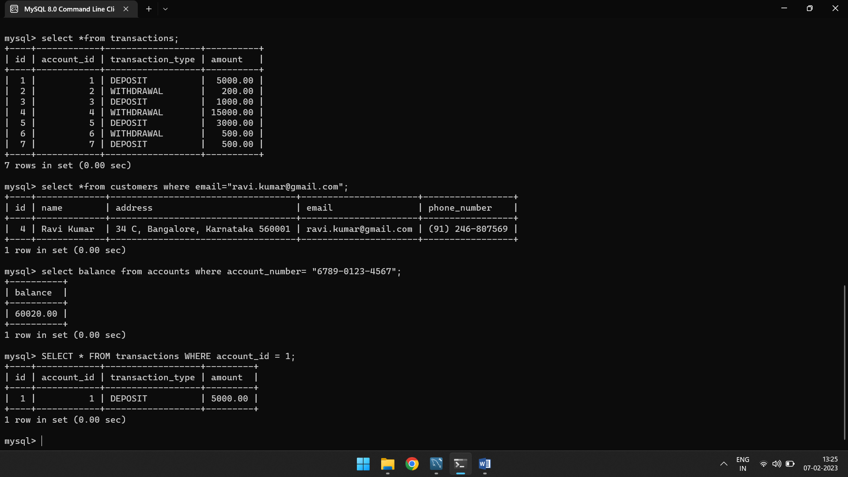

**#Retrieve customer information and account information for a specific customer:**

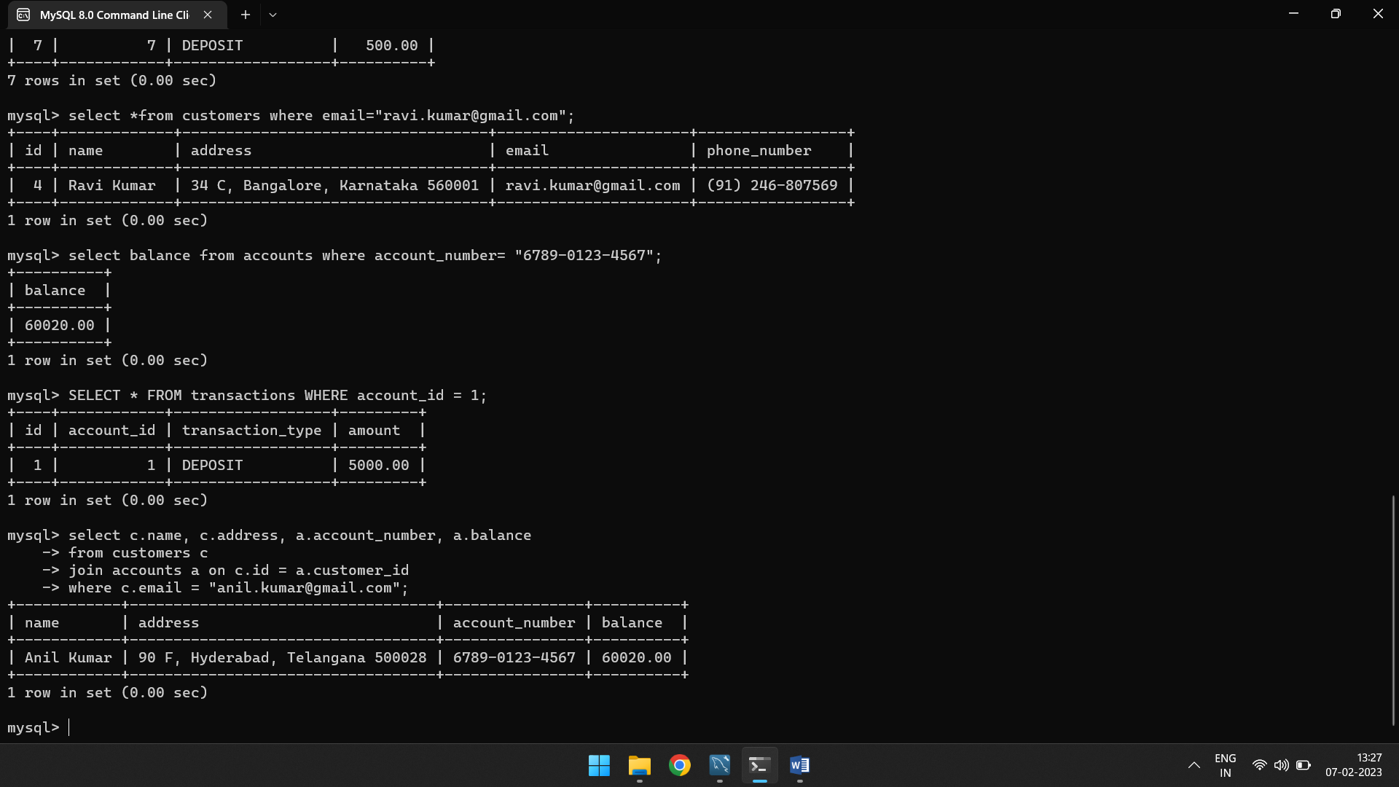

**#Retrieve the name of the customer with the highest balance:**

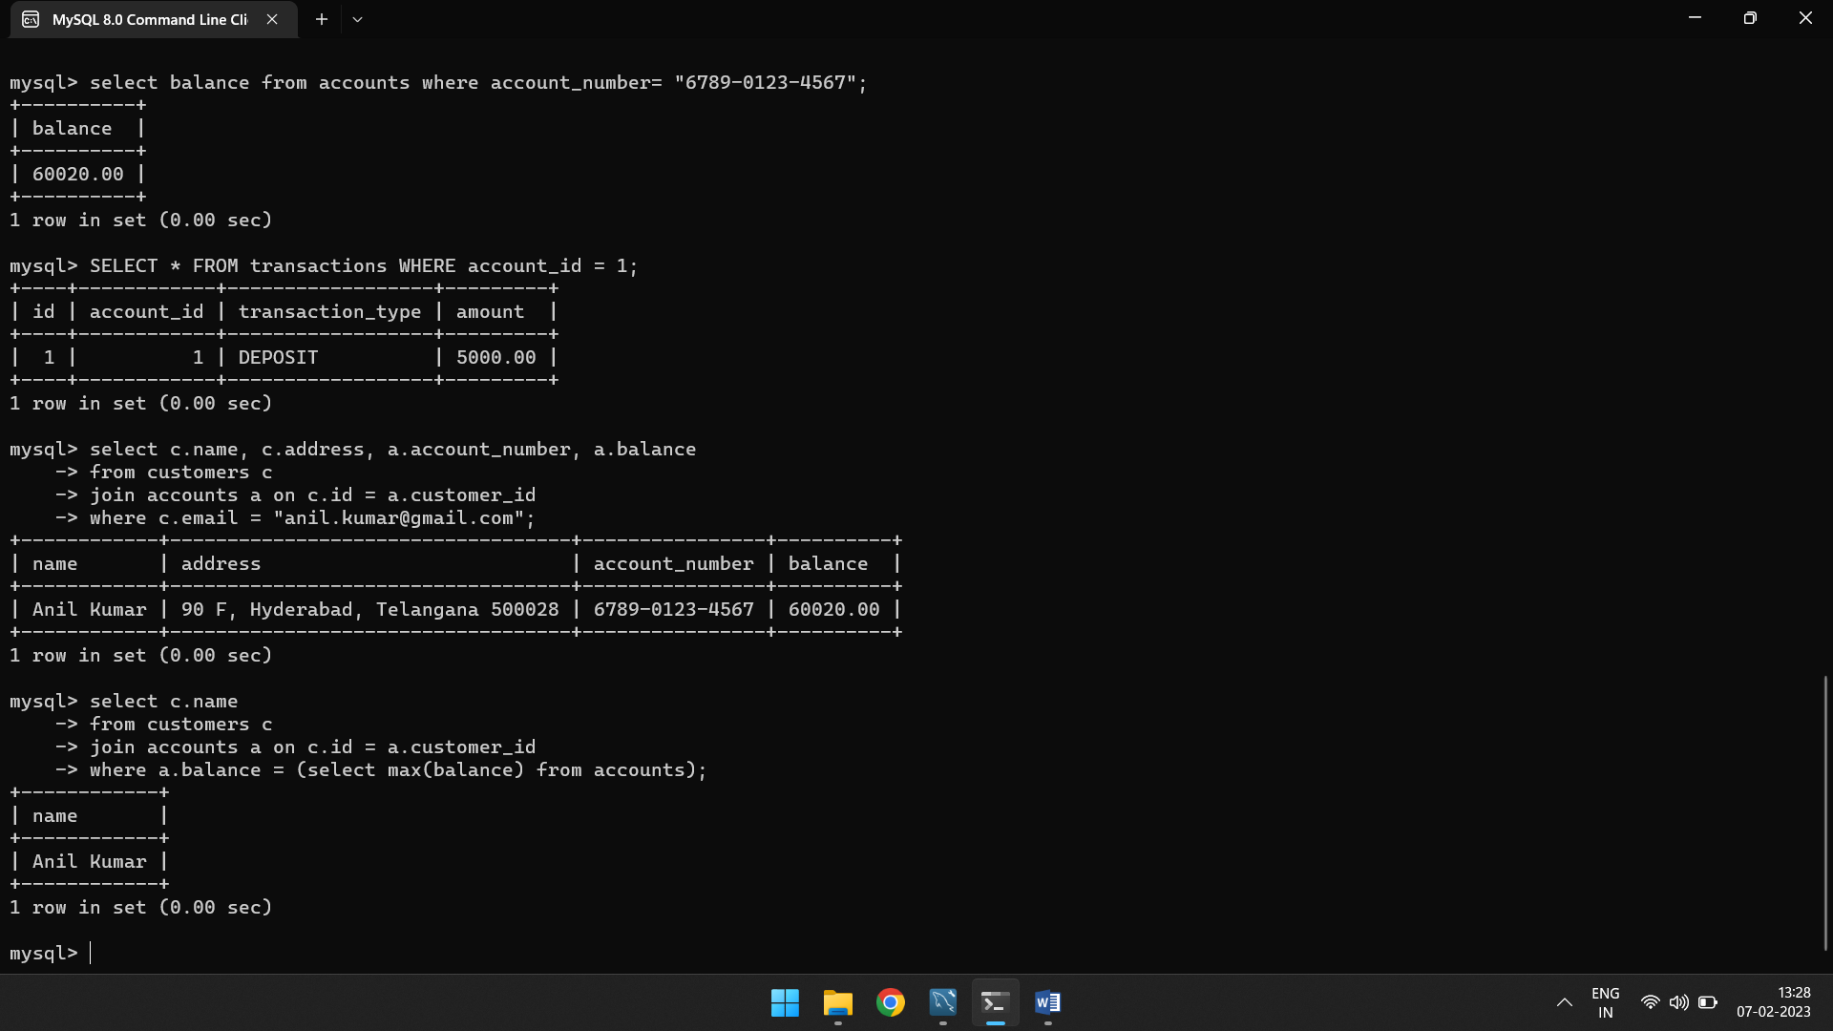

**#Retrieve the total number of transactions for each customer:**

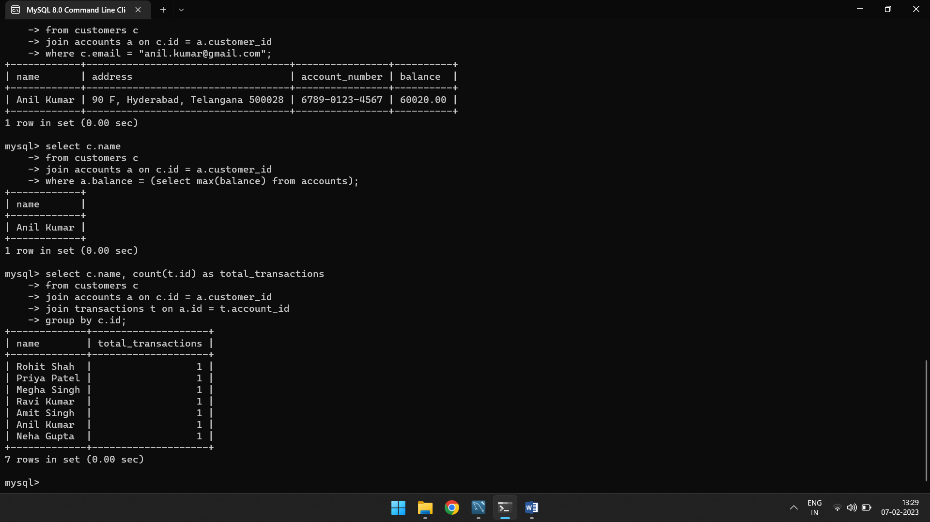

**#Retrieve the average balance for all accounts:**

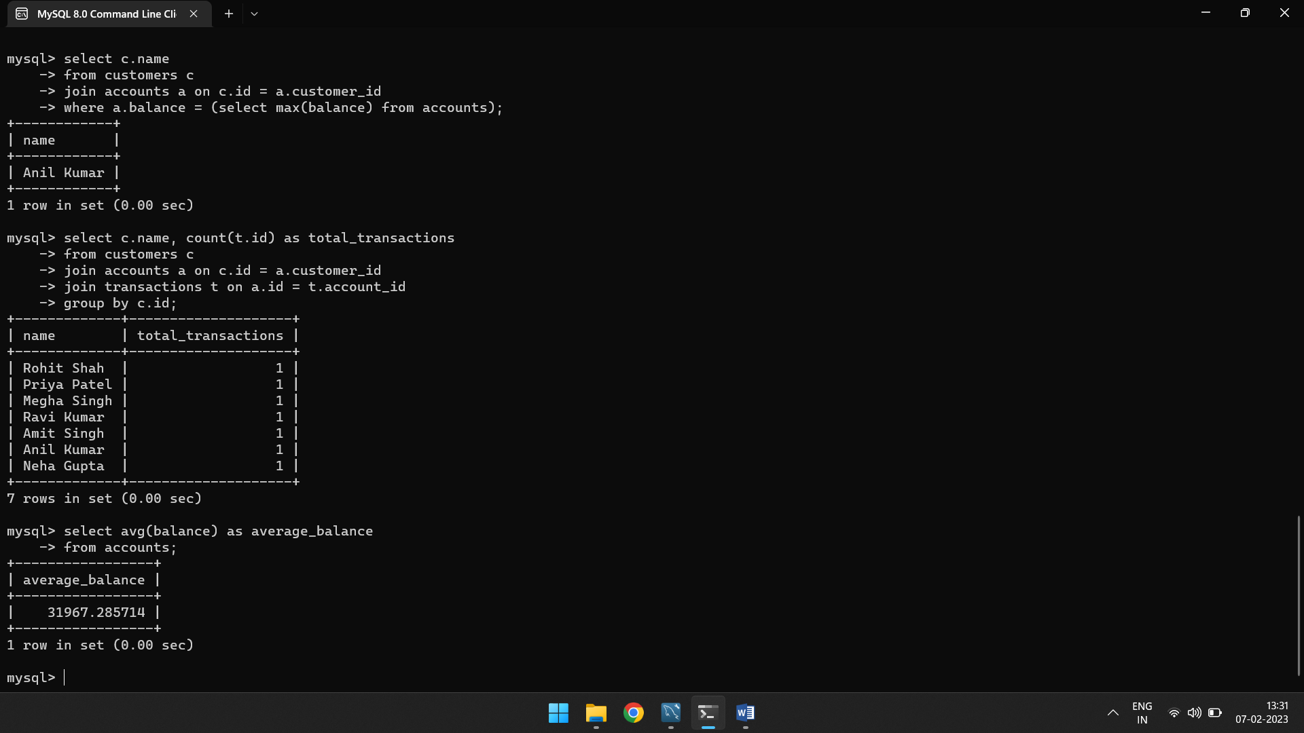

**#Retrieve the name of the customer and their account balance for all accounts with a balance greater than a specified amount:**

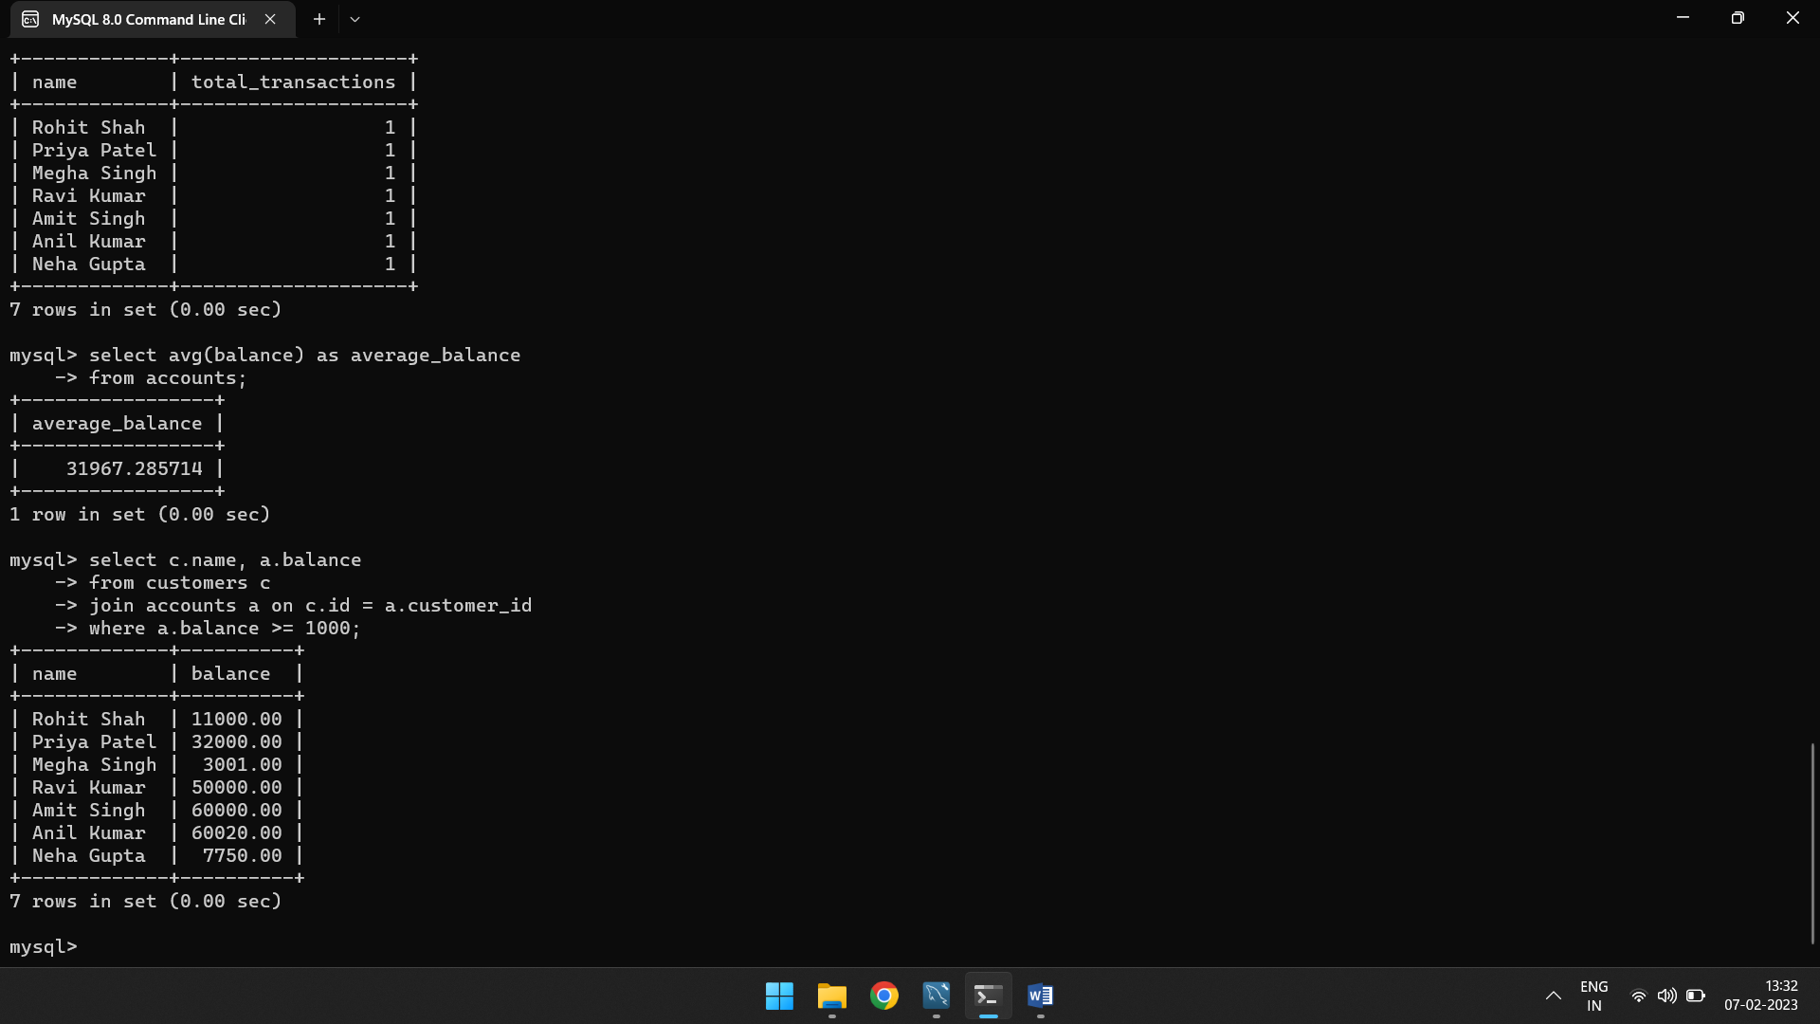

**#Retrive the name of the customer, specific transaction type and their amount**

